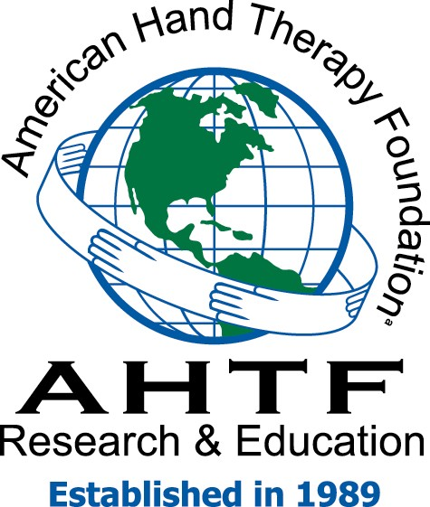
April 4, 2018

Dear Saba Kamal and Membership of the Hand Therapy Association of California:

On behalf of the American Hand Therapy Foundation (AHTF), thank you for supporting the mission and vision of the AHTF. Your generous donation of $10,000 is greatly appreciated and important to our success.

The mission of our organization is to fund clinical and scientific research and education in order to advance the practice of hand therapy and the quality of patient care throughout the world. With your gift, we will be able to support both novice and expert researchers who are able to expand the scientific evidence, visibility, and quality of upper extremity and hand rehabilitation. As part of the funding process, researchers complete standard grant application forms, demonstrate expertise as principal investigators, are responsible for handling budgeted funds, and may collect pilot data for larger funding opportunities.

The AHTF could not do what it does without the support of a caring community. Thank you again for your thoughtful gift to the AHTF and to the clinicians in the hand therapy community who rely on us for services and programs.

The AHTF is a 501(c)(3) nonprofit organization. Your contribution is tax deductible to the extent allowed by law. The AHTF did not provide goods or services in exchange for your financial donation. If you have any questions, please contact the Foundation at ahtf.org. Please retain this letter as your receipt and acknowledgement of the donation. I look forward to opportunities to work with you in the future.

Most sincerely,

Greg Pitts

Greg Pitts
Chair, Board of Directors
American Hand Therapy Foundation

P.O. Box 21992
Lexington, Kentucky 40522

Board of Directors

Greg Pitts, MS, OTR/L, CHT
Chairman , Lexington, Kentucky
pittshand@gmail.com

James W. King, MS, OTR, CHT
Vice Chairman, Houston, Texas
Jking1957@gmail.com

Elaine E. Fess, OTD, MS, OTR, CHT, FAOTA
Treasurer, Zionsville, Indiana
e2indy@aol.com

Dorit Aaron, MA, OTR, CHT, FAOTA
Houston, Texas
dorit@awhand.com

April Cowan, OTD, OTR, CHT
Galveston, Texas
accowan@utmb.edu

Michael Epstein, MD
Houston, Texas
Mepstein.epstein@gmail.com

Mia L. Erickson, EdD, PT, CHT, ATC
Fairmount ,West Virginia
merick@midwstern.edu

Caroline W. Stegink Jansen, PhD, PT, CHT
Dickson, Texas
cwsjansen@gmail.com

Kim McVeigh, MBA, OTR/L, CHT
Jacksonville, Florida
Mcveigh.kimberly@mayo.edu

Gary Soloman, MBA, MS, OTR/L, CHT
Chicago, Illinois
splints@comcast.com

Barbara Winthrop, MA, OTR, CVE, CHT, FAOTA
Houston, Texas
Barbara@awhand.com

Advisory Board
Peter C. Amadio, MD
Kenneth R Flowers, PT, CHT
Karen Lauckhardt MA, PT, CHT
Evelyn Mackin, PT
Terri Skirven, OTR/L, CHT
Robert M. Szabo, MD, MPH

Chairman Emeritus
Jane Bear-Lehman, PhD, OTR, FAOTA
Nancy M. Cannon, OTR, CHT
Elaine E. Fess, OTD, MS, OTR, CHT, FAOTA
Judith Bell Krotoski, MA, LOTR, CHT, FAOTA
Donna Breger Stanton, MA, OTR/L, CHT, FAOTA

